AP CSA FRQ Practice Unit 3

Working with a partner, complete the FRQs below. Please use different color text for your answers.
First - MAKE A COPY of this document.
Then start working with a partner

FRQ 1
SHOW ALL YOUR WORK. REMEMBER THAT PROGRAM SEGMENTS ARE TO BE WRITTEN IN JAVA.
- Assume that the classes listed in the Java Quick Reference have been imported where appropriate.
- Unless otherwise noted in the question, assume that parameters in method calls are not null and that methods are called only when their preconditions are satisfied.
- In writing solutions for each question, you may use any of the accessible methods that are listed in classes defined in that question. Writing significant amounts of code that can be replaced by a call to one of these methods will not receive full credit.

Assume that the following variables have been properly declared and initialized.
- a boolean variable named rsvp
- an int variable named selection, where 1 represents "beef", 2 represents "chicken", 3 represents "pasta", and all other values represent "fish"
- a String variable named option1
- a String variable named option2

(a) Write a code segment that prints "attending" if rsvp is true and prints "not attending" otherwise.
Write the code segment below.
if (rsvp) {
System.out.println("attending");
} else {
System.out.println("not attending");
}
(b) Write a code segment that prints the food item associated with selection. For example, if selection is 3, the code segment should print "pasta".
Write the code segment below. Your code segment should meet all specifications and conform to the example.
switch(selection) {
case 1:
System.out.println("beef");
break;

case 2:
System.out.println("chicken");
break;

case 3:
System.out.println("pasta");
break;

default:
System.out.println("fish");

}
(c) Write a code segment that will store a dinner selection in option1 based on the values of rsvp and selection. The intended behavior of the code segment is described below.
If rsvp is true, the code segment should store in option1 a string indicating the person’s attendance and food choice. For example, if rsvp is true and selection is 1, the following string should be stored in option1.
"Thanks for attending. You will be served beef."
If rsvp is false, the following string should be stored in option1, regardless of the value of selection.
"Sorry you can't make it."
Write the code segment below. Your code segment should meet all specifications and conform to the examples.
if (rsvp) {
switch(selection) {
case 1:
option1 = "Thanks for attending. You will be served beef.";
break;

case 2:
option1 = "Thanks for attending. You will be served chicken.";
break;

case 3:
option1 = "Thanks for attending. You will be served pasta.";
break;

default:
option1 = "Thanks for attending. You will be served fish.";
}
} else {
option1 = "Sorry you can't make it.";
}
(d) Write a code segment that will print true if the strings option1 and option2 contain the same values and will print false otherwise.
Write the code segment below.
if (option1.equals(option2)) {
System.out.println(true);
} else {
System.out.println(false);
}

FRQ2
SHOW ALL YOUR WORK. REMEMBER THAT PROGRAM SEGMENTS ARE TO BE WRITTEN IN JAVA.
- Assume that the classes listed in the Java Quick Reference have been imported where appropriate.
- Unless otherwise noted in the question, assume that parameters in method calls are not null and that methods are called only when their preconditions are satisfied.
- In writing solutions for each question, you may use any of the accessible methods that are listed in classes defined in that question. Writing significant amounts of code that can be replaced by a call to one of these methods will not receive full credit.

This question involves the Draw class, which is used to draw line segments and squares on a 10-by-10 xy-coordinate grid.
public class Draw
{
/** Precondition: All parameters are between 0 and 10, inclusive.
* Draws a line segment in a 10-by-10 xy-coordinate grid.
* The line segment is drawn from (x1, y1) to (x2, y2).
*/

public void drawLine(int x1, int y1, int x2, int y2)
{ /* implementation not shown */ }

/** Precondition: 0 ≤ x < 10, 0 < y ≤ 10, and len > 0.
* Draws a square on a 10-by-10 xy-coordinate grid
* and prints the square’s side length and area.
* The upper left corner of the square will be located
* at the coordinate (x, y) and the side length of the
* square will be len (or as large as will fit in the grid).
*/
public void drawSquare(int x, int y, int len)
{ /* to be implemented */ }
}
The drawLine method, whose implementation is not shown, is used to draw a line segment from the coordinate (x1, y1) to the coordinate (x2, y2). For example, the call drawLine(2, 5, 6, 4) will produce the figure below.
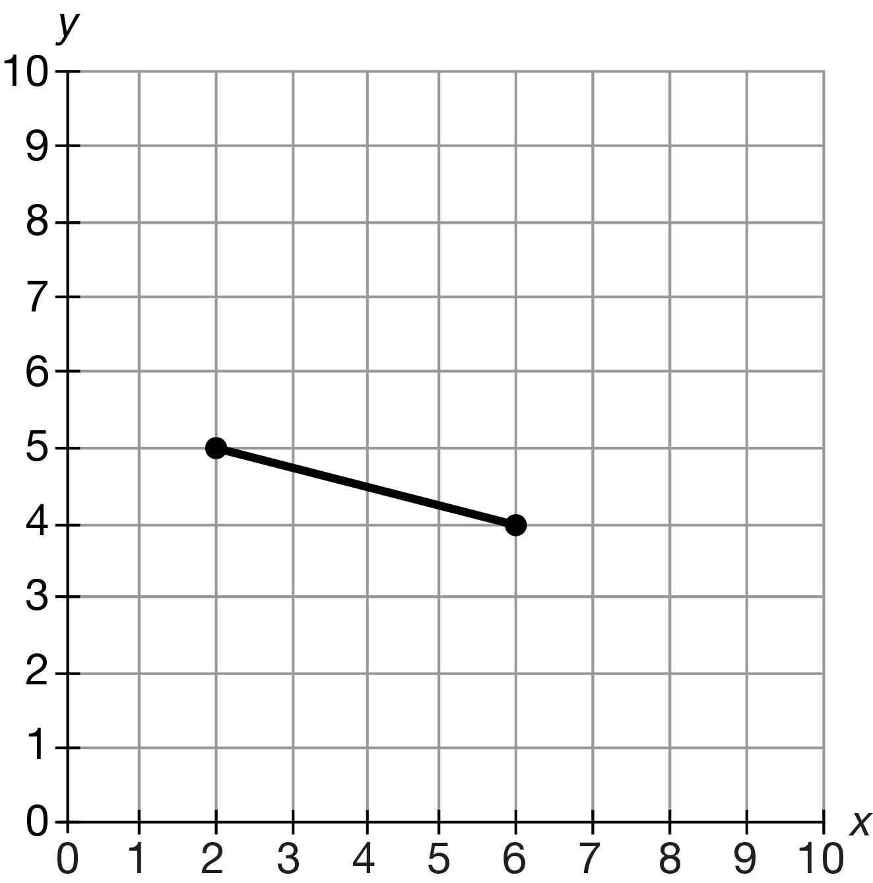
You will write method drawSquare, which draws a square on a 10-by-10 grid and prints the square’s side length and area in the format shown in the examples. The upper left corner of the square is located at the coordinate (x, y). The sides of the square will be of length len, or as large as will fit on the grid.
The following examples show the intended behavior of drawSquare.
Example 1
The call drawSquare(1, 4, 3) will produce the figure below. The upper left corner of the square is at the coordinate (1, 4) and the square has sides of length 3.
The call will print "side length = 3, area = 9".
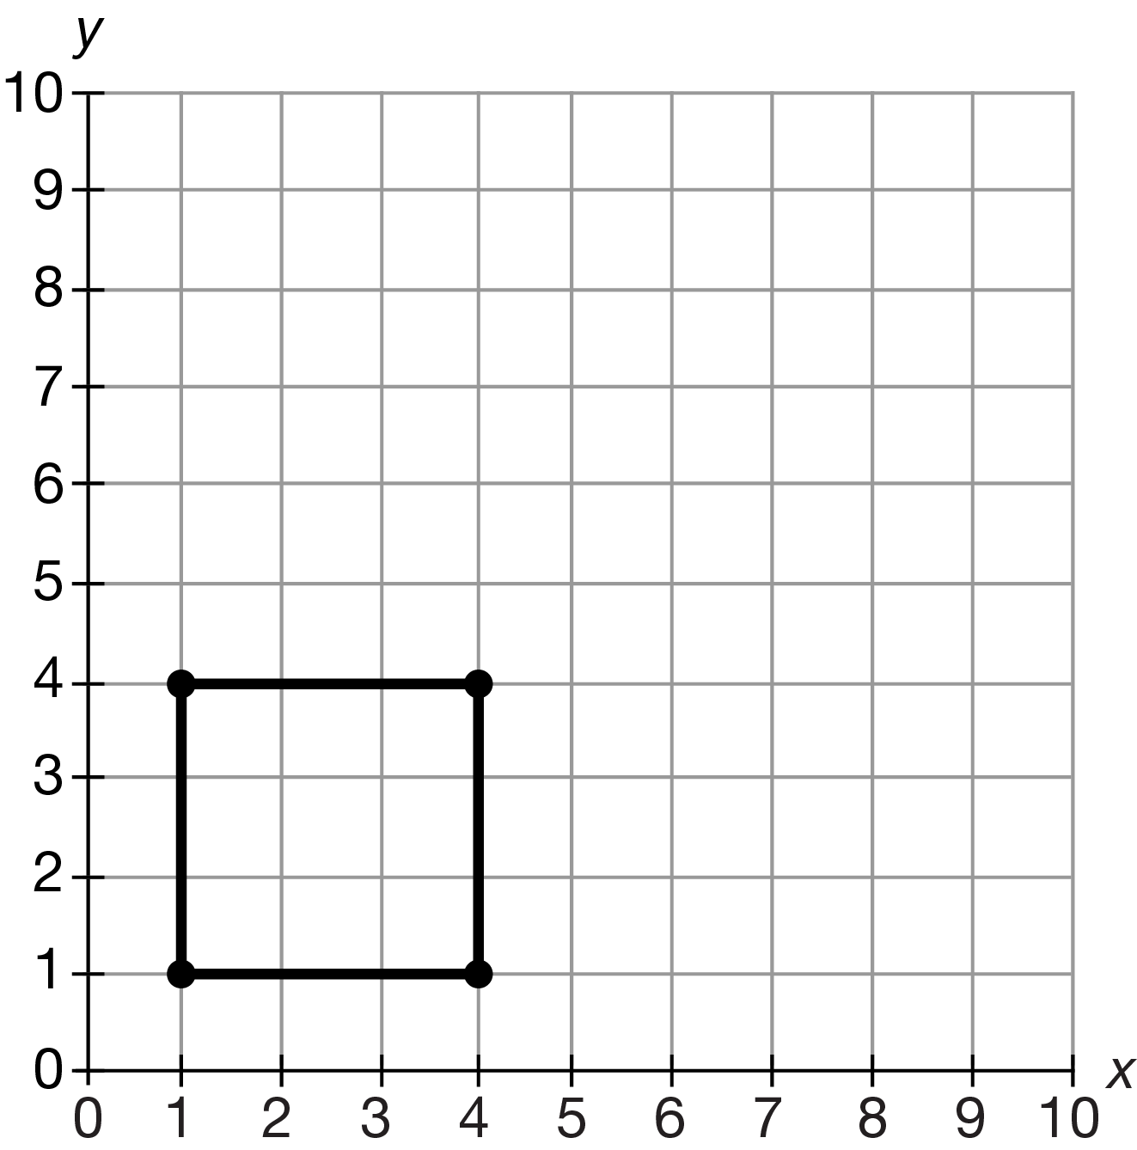
Example 2
The call drawSquare(6, 8, 5) will produce the figure below. A square whose upper left corner is at the coordinate (6, 8) cannot have sides of length 5 and still fit on the grid. The largest possible square (with sides of length 4) is drawn.
The call will print "side length = 4, area = 16".
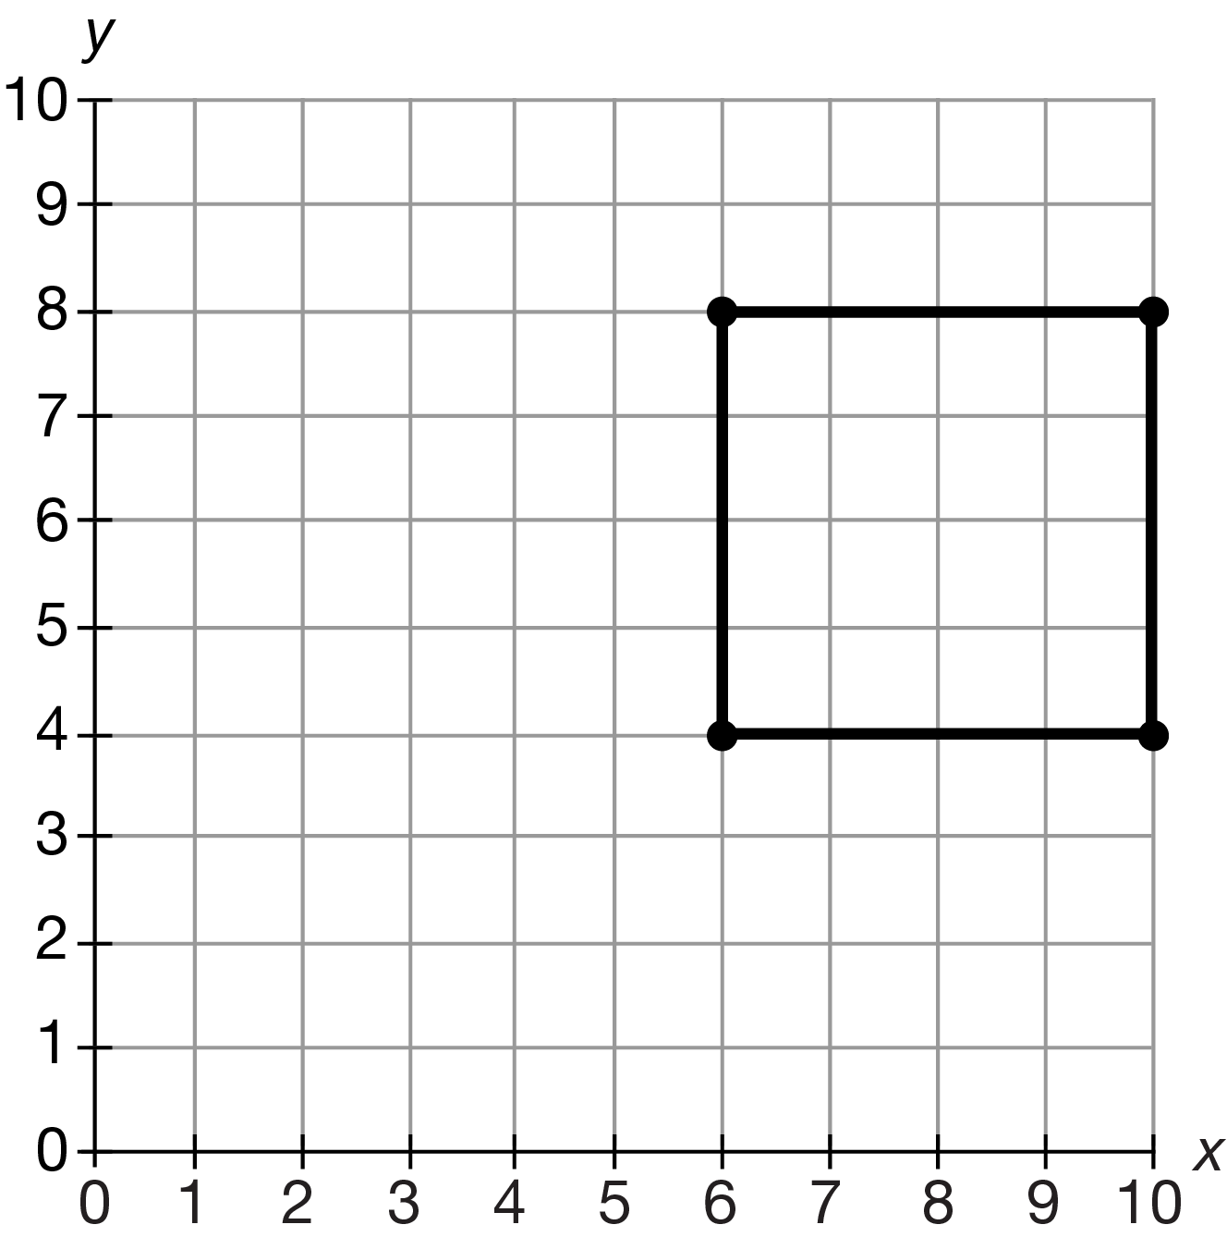
Example 3
The call drawSquare(7, 2, 4) will produce the figure below. A square whose upper left corner is at the coordinate (7, 2) cannot have sides of length 4 and still fit on the grid. The largest possible square (with sides of length 2) is drawn.
The call will print "side length = 2, area = 4".
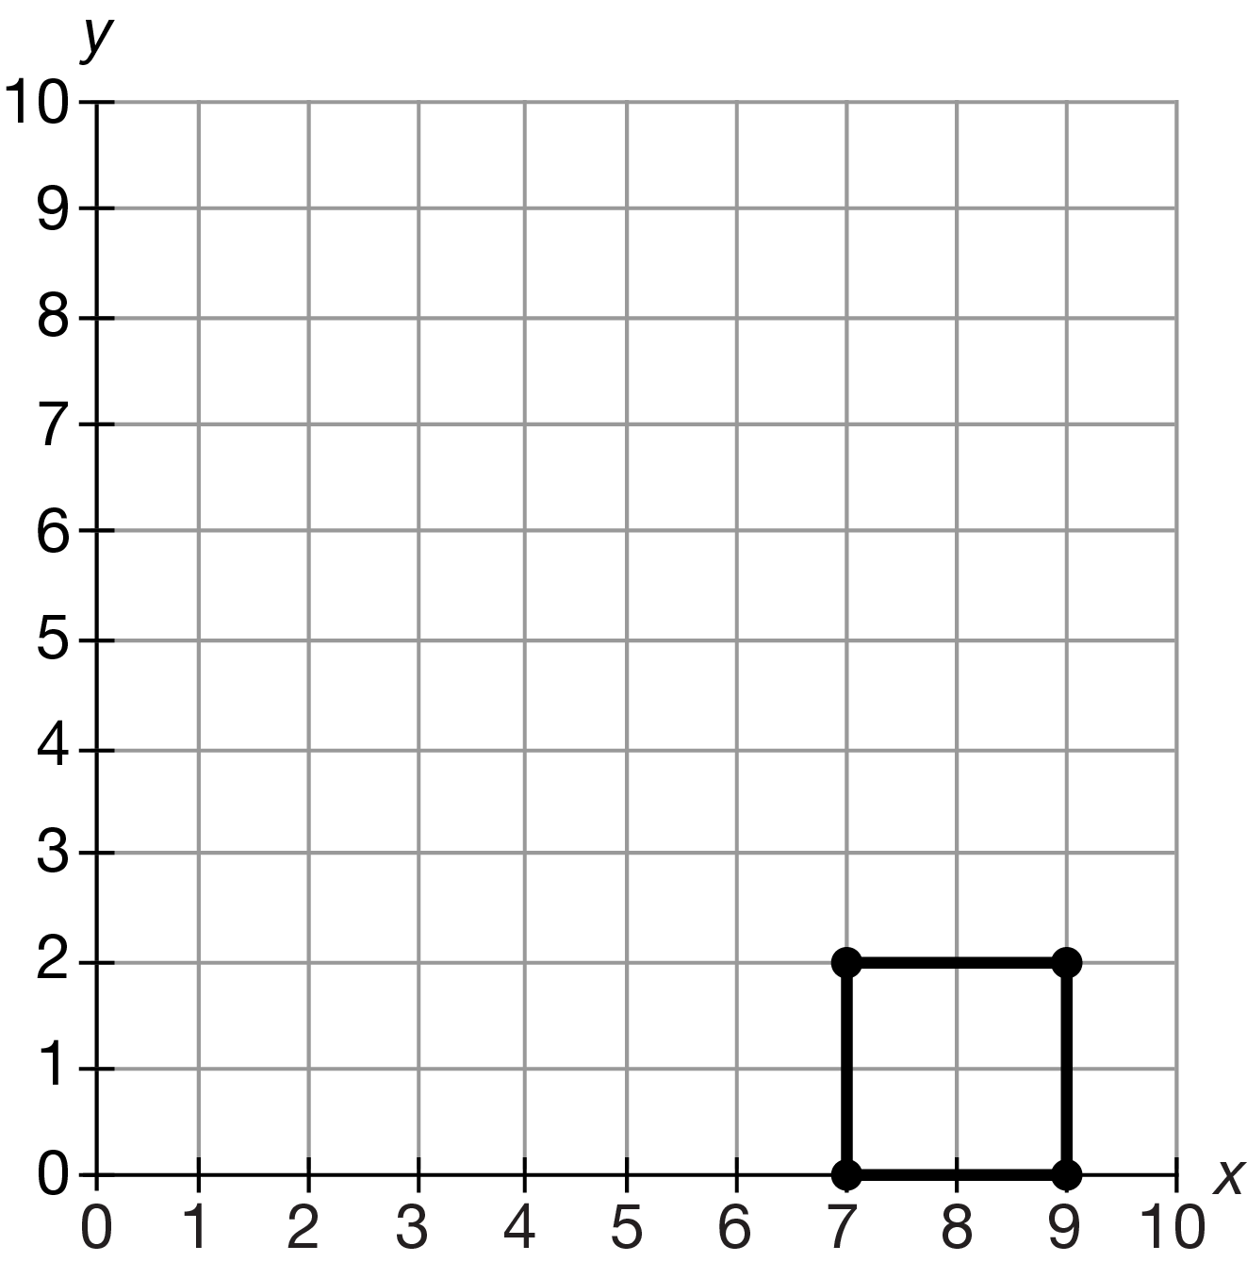
Write the method drawSquare below.

/** Precondition: 0 ≤ x < 10, 0 < y ≤ 10, and len > 0.
* Draws a square on 10-by-10 xy-coordinate grid
* and prints the square’s side length and area.
* The upper left corner of the square will be located
* at the coordinate (x, y) and the side length of the
* square will be len (or as large as will fit in the grid).
*/
public void drawSquare(int x, int y, int len)

// Adjust length if necessary
if (x + len > 10) len -= x;
if (y - len < 0) len = y;

// x1, y1, x2, y2
// Draw square
Draw.drawLine(x, y, x + len, y); // upper
Draw.drawLine(x + len, y, x + len, y - len); // right
Draw.drawLine(x + len, y - len, x, y - len); // lower
Draw.drawLine(x, y - len, x, y); // left

// Print area & side length
System.out.println(“side length = “ + len + “, area = “ + Math.pow(len, 2));

Short Answer FRQS
1) Rewrite the following set of if statements using a nested if-else structure.
if (score >= 90) grade = 'A';
if (score >= 80 && score < 90) grade = 'B';
if (score >= 70 && score < 80) grade = 'C';
if (score >= 60 && score < 70) grade = 'D';
if (score < 60) grade = 'F';
If (score >= 90) {
grade = ‘A’;
} else if (score >= 80 && score < 90) {
grade = ‘B’;
} else if (score >= 70 && score < 80) {
grade = ‘C’;
} else if (score >= 60 && score < 70) {
grade = ‘D’;
} else if (score < 60) {
grade = ‘F’
}
2) A truth table shows, for the various true or false values of boolean variables, what the result of a boolean condition is. Fill in the following truth table. Assume that a, b and c are boolean variables.
Add more columns if you feel you need more clarity to solve the problem,
a b c a && (!b | | c)
false false false false
false false true false
false true false false
false true true false
true false false true
true false true true
true true false false
true true true true

3) A truth table shows, for the various true or false values of boolean variables, what the result of a boolean condition is. Fill in the following truth table. Assume that a, b and c are boolean variables.
Add more columns if you feel you need more clarity to solve the problem,
a b c ! (a && b) | | ! (a && c)
false false false true
false false true true
false true false true
false true true true
true false false true
true false true true
true true false true
true true true false

1) Which of the sets of statements below will add 1 to x if x is positive and subtract 1 from x if x is negative but leave x alone if x is 0? EXPLAIN your answer
a) if (x > 0) x++;
else x--;
Doesn’t work: even if x is zero, it will decrement anyways.
b) if (x > 0) x++;
else if (x < 0) x--;
Works: x ignored if it is not negative or positive
c) if (x > 0) x++;
if (x < 0) x--;
else x = 0;
Works: basically the same as b
d) if (x == 0) x = 0;
else x++;
x--;
Doesn’t work: if x isn’t zero, x will increment and decrement by 1, therefore yielding the same initial value every time
e) x++;
x--;
Doesn’t work: x isn’t even checked for anything and remains the same, as it is incremented and then immediately after it is decremented by the same amount, yielding the same value.

Given the nested if-else structure below, answer questions 2-4.

if (a > 0)
if (b < 0)
x = x + 5;
else
if (a > 5)
x = x + 4;
else
x = x + 3;
else
x = x + 2;

2) If x is currently 0, a = 5 and b = 5, what will x become after the above statement is executed?
X = 3

3) If x is currently 0, a = 0 and b = -5, what will x become after the above statement is executed?
X = 2

4) If x is currently 0, a = 1 and b = -1, what will x become after the above statement is executed?
X = 5

5) Consider the following code that will assign a letter grade of ‘A’, ‘B’, ‘C’, ‘D’, or ‘F’ depending on a student’s test score. EXPLAIN your answer!
if(score >= 90) grade = 'A';
if(score >= 80) grade = 'B';
if(score >= 70) grade = 'C';
if(score >= 60) grade = 'D';
else grade = ‘F’;
a) This code will work correctly in all cases
b) This code will work correctly only if grade >= 60
c) This code will work correctly only if grade < 60
d) This code will work correctly only if grade < 70
e) This code will not work correctly under any circumstances
All of the statements except for the last are if statements, meaning all of the lines will run. If `score` is over 90, it will satisfy all the if statements and therefore grade will still be assigned to D. This error applies to all numbers over 70, which is why the code will only work with numbers under 70.

6) Assume that count is 0, total is 20 and max is 1. The following statement will do which of the following? EXPLAIN your answer.
if (count != 0 && total / count > max) max = total / count;
a) The condition short circuits and the assignment statement is not executed
b) The condition short circuits and the assignment statement is executed without problem
c) The condition does not short circuit causing a division by zero error
d) The condition short circuits so that there is no division by zero error when evaluating the condition, but the assignment statement causes a division by zero error
e) The condition will not compile because it uses improper syntax
Split into precedence:
((count != 0) && ((total / count) > max))
Since count is not equal to zero the && operator will never yield true, therefore the result is false. The condition short circuits and the assignment statement is not executed.

